|  |  |  |  |
| --- | --- | --- | --- |
| **sr.no** | **Main section** | **Subsection** | **Page no** |
| **1** | **Description** |  | **2** |
|  |  | **Over view** |  |
|  |  | **Features** |  |
| **2** | **User Roles** |  | **3** |
|  |  | **Admin Role** |  |
|  |  | **Employee Role** |  |
| **3** | **Admin login** |  | **5** |
|  |  | **Accessing the Login Page** |  |
|  |  | **Enter Login Credentials** |  |
|  |  | **Login to Admin Dashboard** |  |
| **4** | **Admin Dashboard** |  | **5** |
|  |  | **Dashboard** |  |
| **5** | **Manage employees** |  | **6** |
|  |  | **Add employee** |  |
|  |  | **Edit Employee** |  |
|  |  | **Delete Employee** |  |
| **6** | **Category** |  | **7** |
|  |  | **Add category** | **9** |
|  |  | **Display category** |  |
| **7** | **Logout** |  | **10** |
|  |  |  |  |
| **8** | **Employee Login** |  | **11** |
|  |  | **Access login form** |  |
|  |  | **Enter login credentials** |  |
|  |  | **Login to employee details** |  |
| **9** | **Employee Details** |  | **12** |
|  |  | **Employee details** |  |
| **10** | **Data base Schema** |  | **13** |
| **11** | **Summery** |  | **14** |

**Apna Employee**

**Project Name:** Apna Employee (employee management system)

**Date :** 04-09-2024

**Author** : Swaroop kalagouda Patil

**Description:** Apna Employee is an employee management system designed to streamline employee and admin interactions. The system supports role-based access with distinct functionalities for admins and employees.

**Features :**

1. **Role-Based Access Control:**
   * **Admin Login:** Allows admins to log in and access features such as managing employees and viewing statistics.
   * **Employee Login:** Allows employees to log in and view their personal details, including salary and address.
2. **Admin Dashboard:**
   * Provides a comprehensive view of key metrics such as the number of admins, number of employees, and total salary of employees.
   * Includes options to manage employee data and oversee categories.
3. **Employee Management:**
   * **Add New Employee:** Admins can add new employees to the system by providing details such as name, email, salary, and address.
   * **View Employee Details:** Admins can view detailed information about all employees, including their assigned categories.
4. **Category Management:**
   * **Add and Manage Categories:** Admins can create and manage categories that employees can be assigned to, facilitating better organization and reporting.
5. **Employee Dashboard:**
   * **View Personal Details:** Employees can view their own details, including salary, address, and category.
   * Provides a user-friendly interface for employees to access their personal information securely.

These features ensure that both admins and employees have the tools they need to manage and access important information efficiently.

**User roles :**



There are two buttons on this page to redirect the users ,either the user is Admin or Employee

**Admin role:** On this page by clicking on the Admin button ,it will redirect to the Admin login page

• **Access Level:** Full

• **Capabilities:** View dashboard, manage employees, manage categories, log out

**Employee role** : On this page by clicking on this employee button , it will redirects to the Employee login page

• **Access Level:** Limited

• **Capabilities:** View personal details, view salary, view address, view category

**Admin Login :**

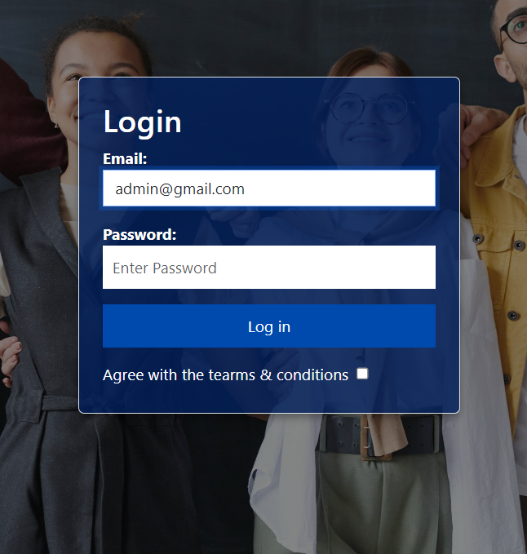

**Enter Login Credentials:**

**Email Address** : Enter the email address of the Admin .

**Password** : Enter the password you created.

**Login to Your Account**:

Click the "Login" button to access your account. If your credentials are correct, you will be logged in and redirected to the Admin Dashboard.\

**Error Handling:**

If you enter an incorrect email or password, an error message will be displayed. check your credentials and try again.

**Admin Dashboard :**

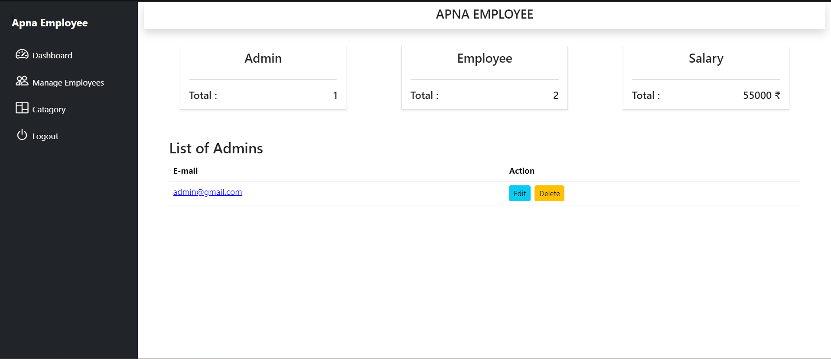

**Dashboard Overview**

* **Statistics:** Number of admins, number of employees, total salary of employees

• Total labor cost

• Distribution of employees by department or category

• Employee turnover rate

• Diversity and inclusion metrics

* **Manage Employees:** Add new employees, view employee details

• Edit employee information

• Delete employees

* **Manage Categories:** Add and manage employee categories
  + Assign employees to categories
  + Add new caterory

**Manage employees :**

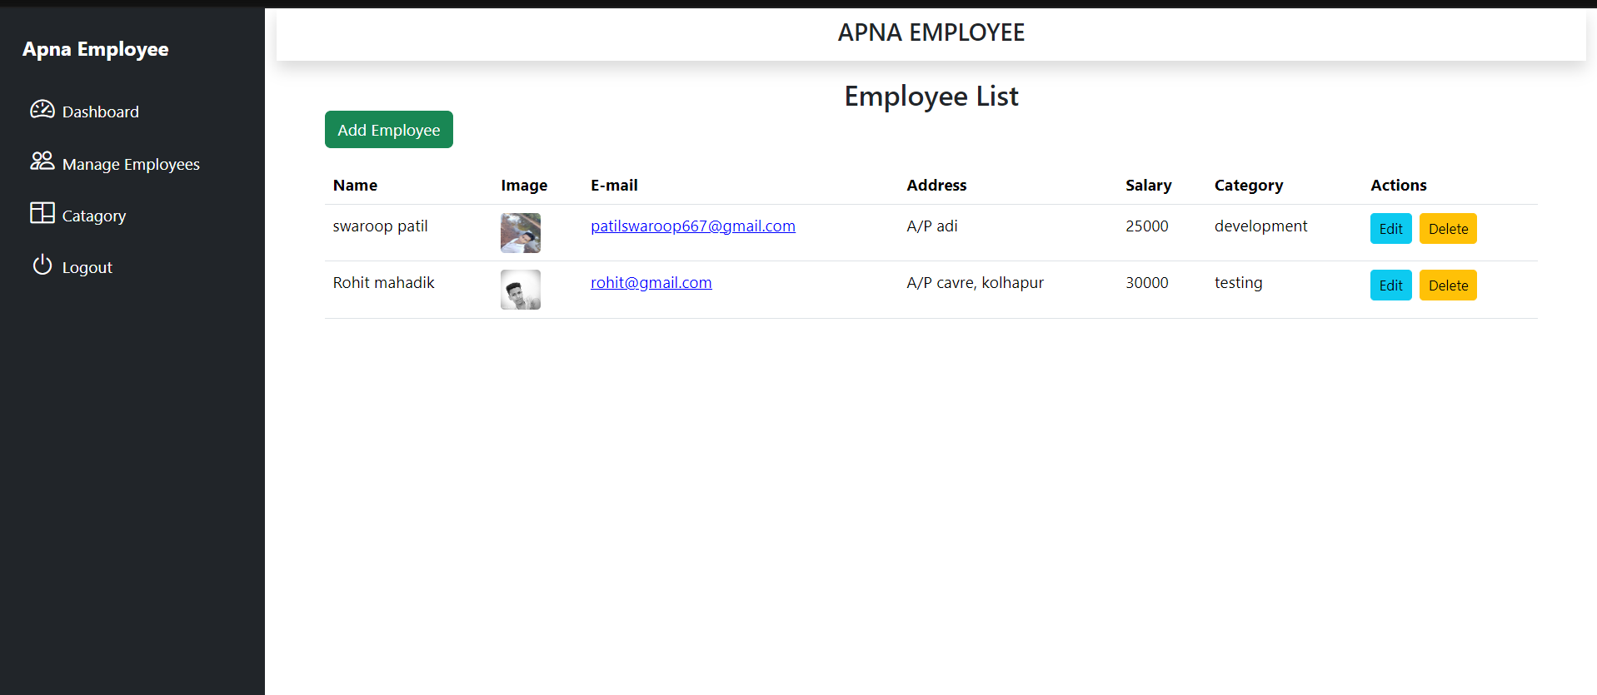

* On clicking the manage employee this page appers , where all employees are displayed
* **Add Employee Button:** A prominent button at the top right corner allows users to add new employees, it gives access the form where the details of the new employee can be added along with employees image
* **Employee List:** The main section of the dashboard displays a list of existing employees, including their Name, Image, E-mail, Address, Salary, Category, and Actions.
* **Employee Details:** For each employee, the list shows their name, a profile picture, email address, address, salary, category, and two action buttons: "Edit" and "Delete."
* **Action Buttons** : Buttons allows user to edit the particular record and Delete the particular record

**Add Employee** :

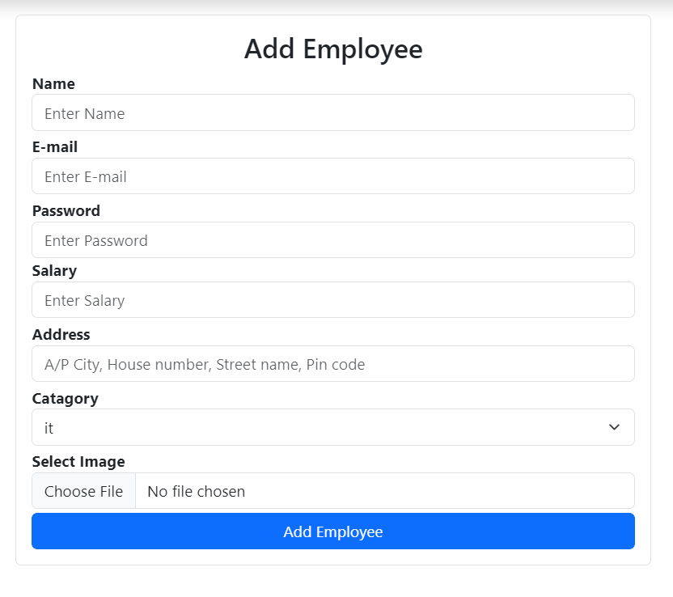

Add employee page provides the form where all the essential information about the employee can be added

**Add Employee Details:**

* **Name:** Enter employee name
* **Email:** Enter employee email
* **Category:** Select the category
* **Salary:** Enter the salary
* **Address:** Enter the address
* **Image :** Select the image of the employee

After filling all the information about the employee

Press **Add Employee** button to store the details of the Employee.

**Category :**

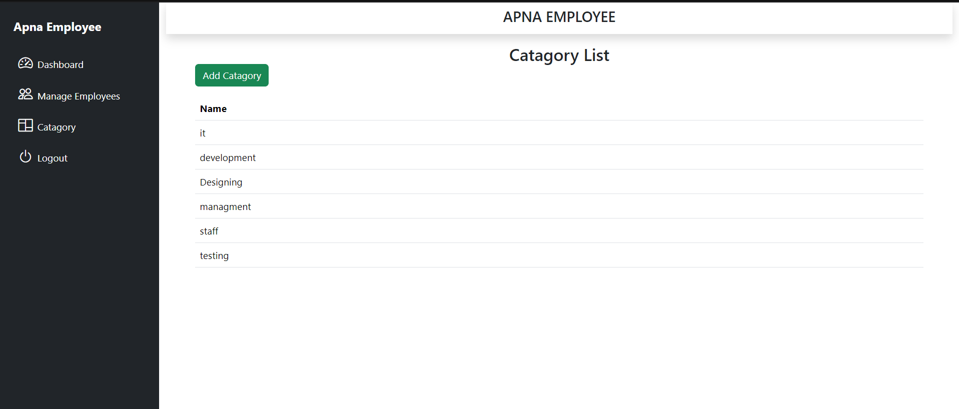

By clicking category button then this page will be provided

• **Add Category Button:** A prominent button at the top right corner allows users to add new employee categories.

• **Category List:** The main section of the page displays a list of existing employee categories, including their names.

• **Category Details:** The list shows the name of each category, and potentially additional details or actions depending on the system's functionality.

Overall, the "Category List" page provides a simple interface for managing employee categories within the "Apna Employee" system.

**Add Category :**

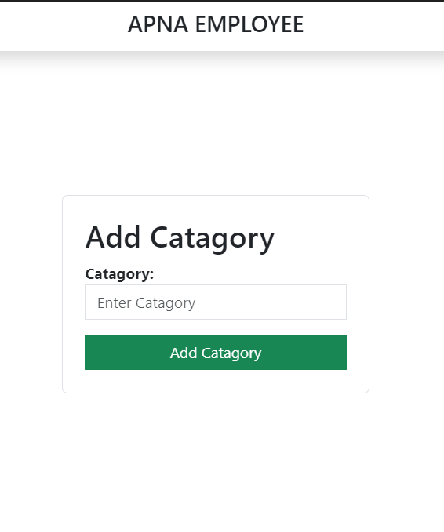

This page appears when add category button is clicked ,to add new category and same is displayed in the category list, which can be used in the add employee form to select category of the employee

• **Input Field:** Provides a space for users to enter the name of the new category.

• **"Add Category" Button:** When clicked, submits the form data and creates the new category in the system

**Logout :**

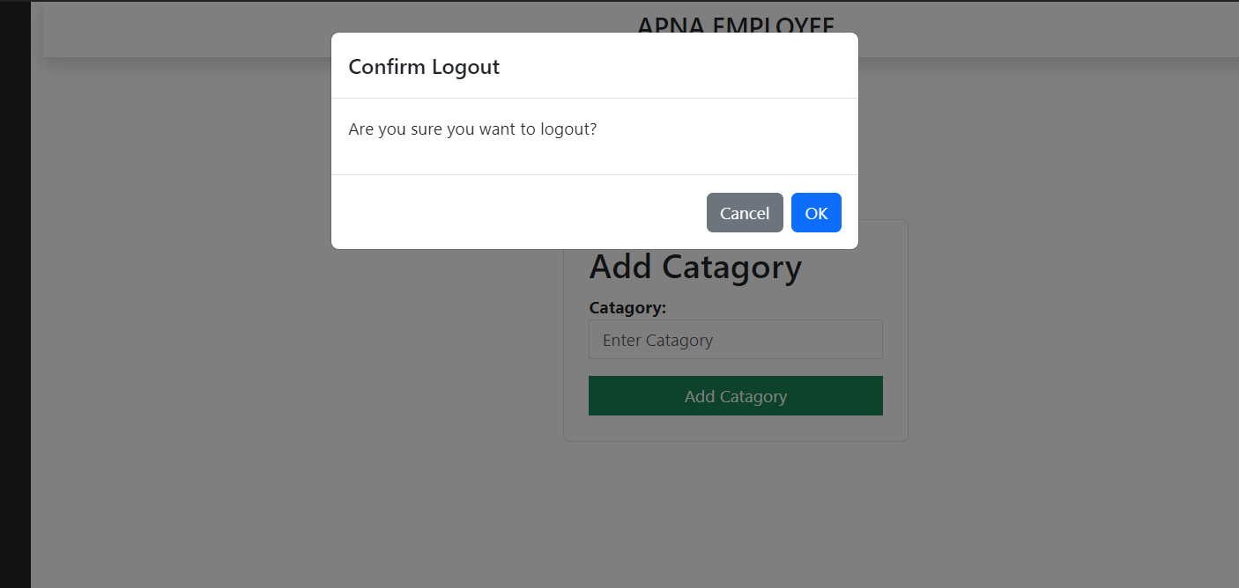

When logout button is clicked then logout confermation massage is appered

• **Confirmation Message:** Displays a message asking the user to confirm if they want to log out.

• **"Cancel" Button:** Allows the user to cancel the logout action and remain logged in.

• **"OK" Button:** Allows the user to confirm the logout action, which will terminate their current session and take them back to the login page.

• **Modal Behavior:** The dialog box typically appears as a modal, preventing the user from interacting with other parts of the application until they choose to either cancel or confirm the logout.

• **Security:** This confirmation dialog box is a security measure to prevent accidental or unauthorized logouts.

**Employee Login :**

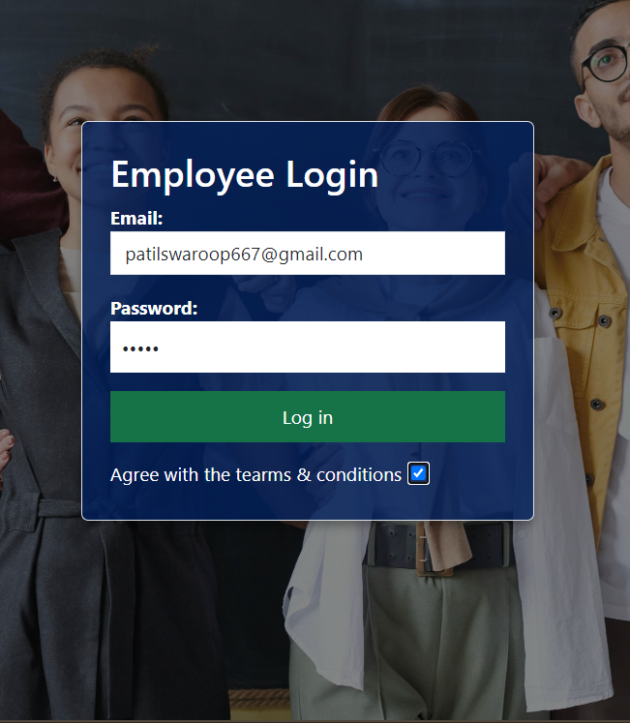

**Enter Employee Login Credentials:**

**Email Address** : Enter the email address of the employee .

**Password** : Enter the password of employee.

**Login to Your Account**:

Click the "Login" button to access your account. If your credentials are correct, you will be logged in and redirected to the employee detail page.

**Error Handling:**

If you enter an incorrect email or password, an error message will be displayed. check your credentials and try again.

**Employee Details :**

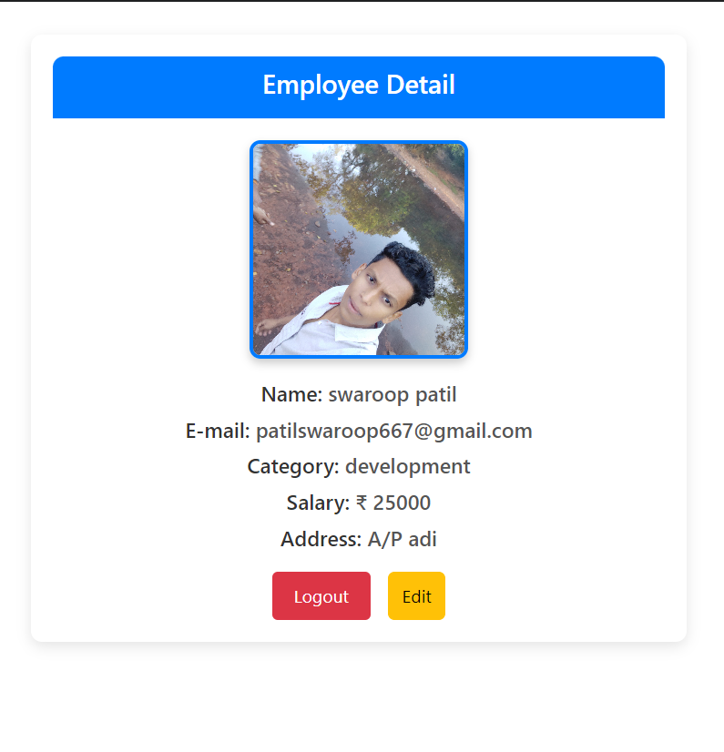

• **Employee Detail View:** The page displays specific information about a particular employee, including their name, email, category, salary, and address.

• **Logout Functionality:** The "Logout" button allows the current user to terminate their session and exit the application.

• **Edit Functionality:** The "Edit" button likely provides access to a form or page where the employee's information can be modified or updated.

• **Category Display:** The "Category" field indicates the employee's assigned department or role within the organization.

• **Basic Employee Management:** The page serves as a fundamental tool for viewing and potentially managing employee details within a human resources or employee management system.

**Data base Schama:**

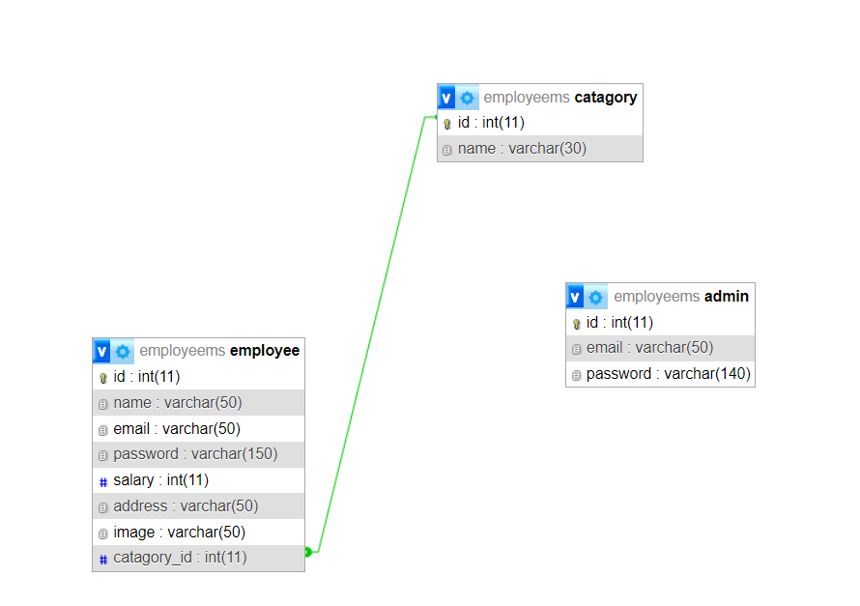

The ERD illustrates the relationships between three tables: employees, categories, and admins.

* The employees table stores information about individual employees, including their name, email, password, salary, address, profile image, and category.
* The categories table stores information about different employee categories or departments.
* The admins table stores information about administrators who have access to manage employees and categories.

**Summery:**

The "Apna Employee" project is a comprehensive employee management system designed to streamline administrative and personal tasks within an organization. The system features role-based access control, distinguishing between admin and employee functionalities to ensure appropriate access levels. Admin users can log in to an intuitive dashboard that provides key metrics such as the number of admins, employees, and the total salary expenditure. From this dashboard, admins can manage employee records, add new employees, and oversee categories to which employees are assigned. On the other hand, employees can log in to access their personal dashboard, where they can view and manage their own details, including salary, address, and assigned category. This dual-role approach enhances operational efficiency and facilitates effective management and communication within the organization.